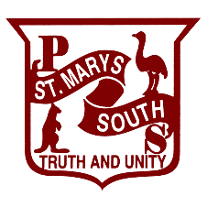
ST MARYS SOUTH PUBLIC SCHOOL
INNOVATE | CREATE | COLLABORATE | COMMUNICATE | THINK CRITICALLY

Voluntary School Contribution

Dear Families
Each year the school asks you for financial support through a voluntary contribution.
Funds raised through voluntary contributions are used to enhance educational programs. In the past, this helps pay for fitness, school incursion/excursion costs, and resources for Music, Art, and Sport.
These contributions are always voluntary.
Please consider making this payment. You can pay electronically at the school office or via school bytes secure online payment system.
In 2023, the voluntary contribution structure is as follows:
- 1 child attending school - $35.
- 2 children attending school - $60.
- 3 or more children attending school - $70.
I am happy to meet with you if you have any questions about the voluntary contribution.
If you have already paid your child’s voluntary contribution fee, please disregard this letter, and I thank you for your support.

Kind regards,

Miriam Treton
Principal
Monday, 5 February 2024.

